RESEARCH PROPOSAL

EFFECTIVENSS OF THE CLOTHING AND TEXTILE COMPETITIVENESS PROGRAMME

Department Code : MTEIS1

Philisa Mangakane : 213562231

Masters in Technology : Industrial Engineering

DATE : 1 June 2015
CONTENTS

Table of Contents
1. Background 3
1.1. Job Losses Challenges 3
1.2. Textile Industry Stakeholders 3
1.3. Supply Chain 5
1.4. Government Interventions 6
1.4.1. US’ African Growth and Opportunity Act 6
1.4.2. Regional Textiles Cluster 6
1.4.3. Clothing Textile Customised Sector Programme (CSP) 6
1.4.4. AIM 9
The research aims to assess to what extent the CTCP meets its objectives in order to: 9
2. RESEARCH QUESTION AND SUB QUESTIONS 9
3. Methodology 10
3.1. Research Design 11
3.1.1. Data Collection Design 11
3.1.2. Sampling design 11
3.1.3. Proposed Table of Contents of the research report 12
4. DATA ANALYSIS 12
5. ETHICS 12
5.1. Ensuring participants have given formal consent 13
5.2. Ensuring no harm comes to the participants 13
5.3. Ensuring confidentiality and anonymity 13
5.4. Ensuring that permission is obtained 13
6. COPYRIGHT 13
7. TIME SCHEDULE 13
8. SUPPORT STAFF 14
9. BUDGET 14
10. RECORDS 15
11. PUBLICATIONS 15
12. References 15

Table 1 Budget 14

Figure 1: Textile Industry Stakeholders 5
Figure 2: Textile Industry Supply Chain 5
Figure 3: Clothing and Textile Customised Sector Programme Pillars 7
Figure 4: Clothing and Textile Competitiveness Programme Components 7
Figure 5 Research framework 10
Figure 6 Proposed schedule of the research study in Gantt chart format 14

Effectiveness of the clothing and textile competitiveness program

Background

Industrial Policy Action Plan (2015:11) describes the role of manufacturing as having substantial direct employment-creation potential and the engine of rising per capita income and employment through its stimulation of the rest of the economy and as a critical and indispensable driver of innovation and productivity growth.

According to the Industrial Policy Action Plan (2015:73), the textile manufacturing sector in South Africa in 2011 accounted for 0.7 % manufacturing value add towards Gross Domestic Product (GDP).

The textile industry is facing various challenges from job losses to international competition. Job losses Statistics South Africa reported (2015:2) that employment in the manufacturing sector decreased by (-16 000 or -0.5%) year on year between March 2014 and March 2015 though there were increases reported by manufacturing industry (4 000 or 0,4%).

Job Losses Challenges
- Raw materials imports due to the perception that the local industry does not have capabilities of producing certain raw materials.
- Imports of completed manufactured clothing garments from China and other Asian countries due to their advantage of low costs of labour.
- Incorrect tariffs heading on imported goods.
- High labour costs resulting to subcontracting of labour to neighbouring countries such as Lesotho due to their cheaper labour rates.
- Cashflow challenges by the small, medium, micro and large enterprises (SMME) manufacturing clothing to pay their raw material suppliers and sustain the business.
- Rand Volatility with the stronger rand impacting negatively on exports.
- Increasing costs of inputs such as electricity, transportation, raw material.
- Skills and competitiveness shortages

Textile Industry Stakeholders
The textile industry consists of stakeholders outlined in Figure1 below which are as follows:
- Suppliers of raw material such as the fibres, yarn, finishing chemicals and dyes.
- Fabric manufacturers who process the yarns into fabric, knit, weave and dye the fabric.
- The clothing manufacturing companies consisting of SMME which cut, make and trim (CMT) the fabric into garments.
- Retailers, who buy from manufacturers and sell to consumers,.
- Users comprising of government entities such as the South African Police Services, South African National Defence Force and South African Correctional Services, government hospitals as well as the domestic and industrial users who buy directly from the manufacturers or from the retailers and domestic users.
- Textile clusters such as the Southern African Sustainable Textile and Apparel Cluster (SASTAC) representing the manufactures and the raw material suppliers; responsible for the development of a database of local textile production capability and availability. The Department of Trade and Industry (Dti) and South African Bureau of Standards (SABS) are also represented in this cluster.
- Textile labour association such as Southern African Clothing and Textile workers union (SACTW) representing workers and their rights in the industry.
- International Trade Administration Commission (ITAC) responsible for international trade administration, enhancing economic growth and development by conducting tariff investigations, trade remedies and import and export control.
- Inspection authorities such as SABS responsible for generation of national specifications and standards, testing, inspection of materials, manufactured garments and manufacturing facilities and certification.
- Dti, responsible for ensuring the sustainability of the industry by initiating funding programmes, quotas on imports, import duties and local content regulations.
- South African Revenue Services responsible for clamping down on the illegal imports that have been flooding the country, using documentation that under-invoices consignments
- Southern African Customs Union (SACU) consisting of South Africa, Namibia, Botswana, Lesotho and Swaziland focusing on tariff policies, customs policies, trade agreements in promoting regional integration and economic development of all its member states.
- National Bargaining Council for the clothing manufacturing industry represented by registered union parties and registered employer’s organisation, the powers and functions of the council are defined in the constitution.
Raw material manufacturers

Bargaining Council
Retailers
Labour Associations
SARS
SACU

DTI and IDC

Inspection authorities

Textile Cluster

Users

Clothing Manufactures

Fabric manufacturers
Textile Industry Stakeholders

Figure 1: Textile Industry Stakeholders

Supply Chain

The supply chain of the industry is as depicted on Figure 2 below.

Raw material producers

Clothing Manufacturers
Fabric Manufacturers

Retailers

Users

Figure 2: Textile Industry Supply Chain

Raw materials consist of fibres and yarn.

Government Interventions

US’ African Growth and Opportunity Act
The US’ African Growth and Opportunity Act (AGOA) signed in 2000 benefits African countries by providing incentives for exports opportunities to the US through trade and investment expansion with the United States (US).

According to Barnes (2005:8), trade agreements such as AGOA not only provide export opportunities, but also create the potential for access to cheaper inputs, as well as technology.

AGOA imports by US from South Africa for the 2014 year (January to December) amounted to $8, 307, 59 and South Africa was one of the top five countries that benefited from the AGOA US imports (Department of Commerce, International Trade Administration 2014:1).

Regional Textiles Cluster
The Kwa-Zulu Natal and the Cape clothing textile clusters were initiated in late 2004 and early 2005 following a similar model to that of the Durban Auto Cluster. Both clusters were launched with programmes solely focused on ensuring manufacturing excellence upgrading - collective efficiency, knowledge sharing, and continuous improvement learning activities (Morris and Barnes 2006:10).

Clothing Textile Customised Sector Programme (CSP)
Government through the Dti’s strategic approach to restructuring the textile industry with the objective of ensuring the long term sustainability and competitiveness has initiated a Clothing Textile Customised Sector Programme (CSP).

Its main objective is to assist industry in upgrading processes, products and people to re-position it so it can compete effectively against other low cost producing countries.

This programme has various projects running aimed at creating sustainability capabilities and employment in the Clothing, Textiles, Footwear, Leather and Leather Goods Industries as indicated in Figure 3 below.

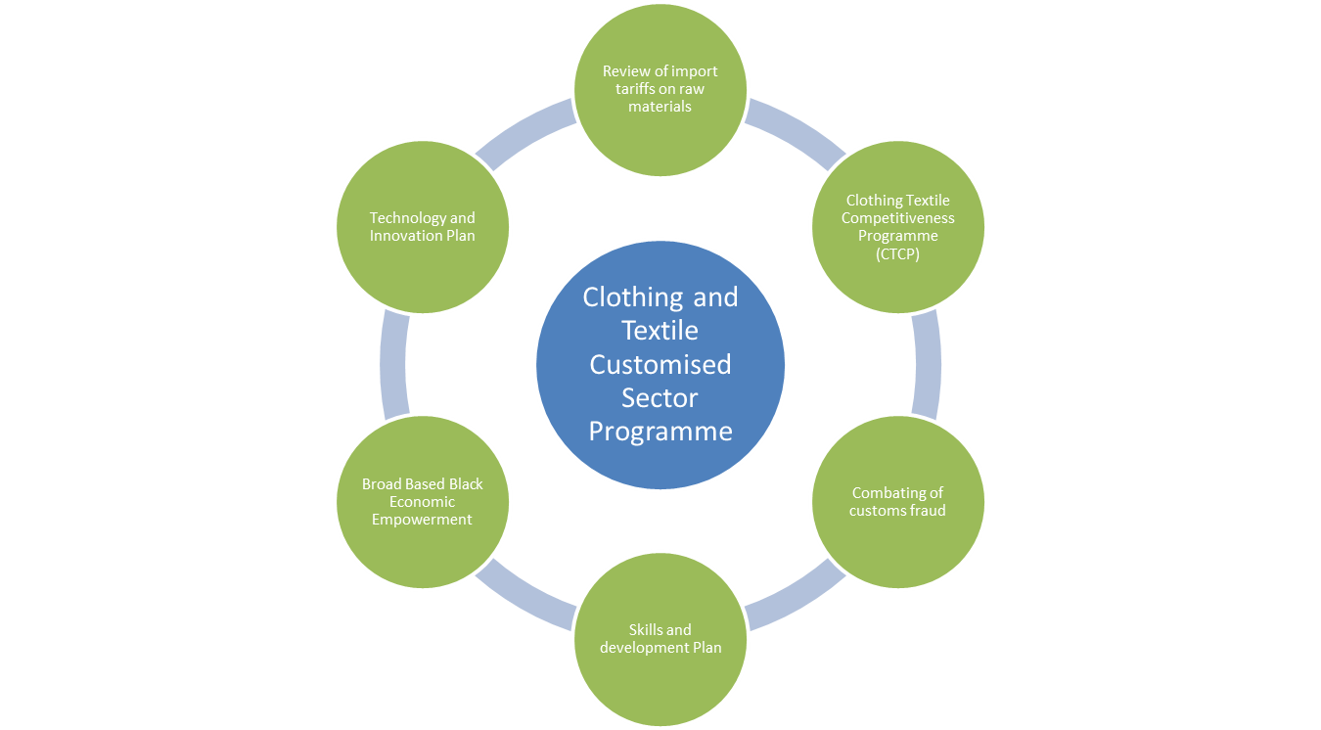

Figure 3: Clothing and Textile Customised Sector Programme Pillars

The focus of the research is on one of CSP pillars namely, the Clothing and Textile Competitiveness Programme (CTCP).

This programme is aimed at structurally changing the industry by providing funding assistance to the Clothing, Textiles, Footwear, Leather and Leather Goods Industries for these industries to invest in competitive interventions (Department of Trade and Industry,S.a) and it consists of two components indicated on Figure 4 below.

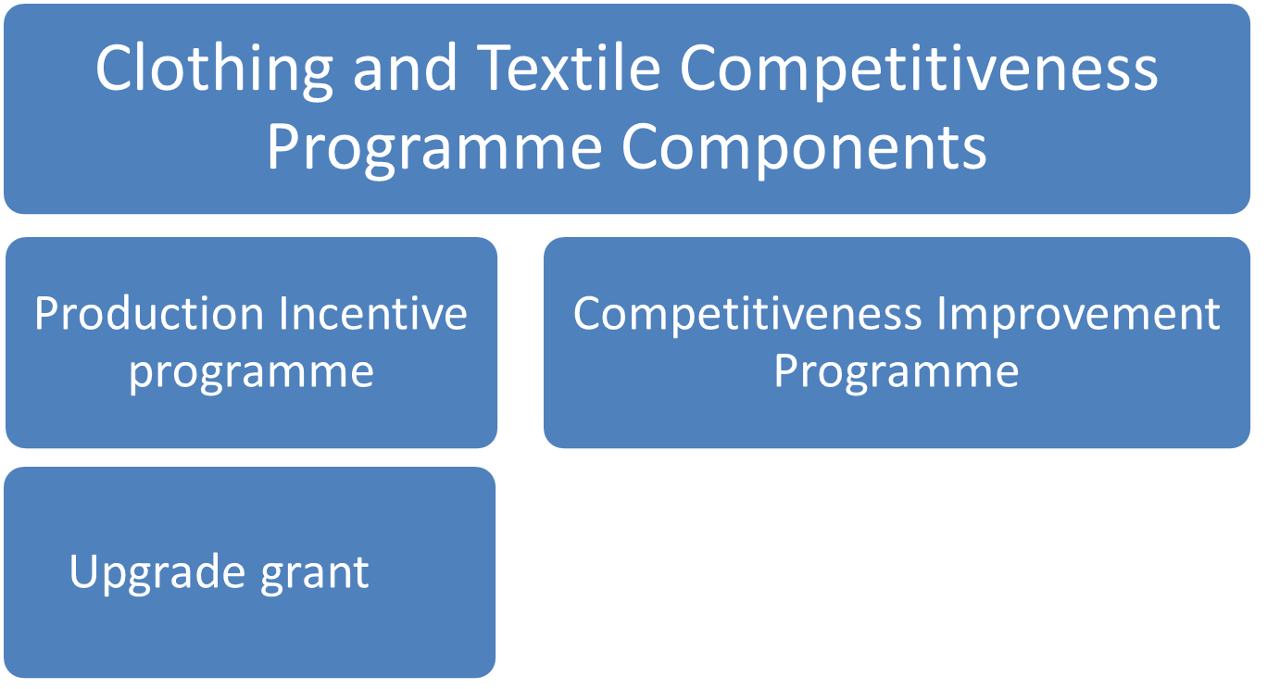
Clothing and Textile Competitiveness Programme Components
Figure 4: Clothing and Textile Competitiveness Programme Components

Clothing and Textile Competitiveness Programme
The CTCP’s main objective is to assist industry in upgrading processes, products and people to re-position it so that it can compete effectively against other low cost producing countries (Department of Trade and Industry, S.a).

Production Incentive Programme
The Production Incentive Programme (PIP) is meant to encourage and support upgrading and competitiveness improvement programmes in the sector through grant provision (Department of Trade and Industry, 2014).

The PIP incentive offered to companies is equal to 7.5% for the year ending 31 March 2015 of a company’s Manufacturing Value Addition (MVA). The PIP is calculated as follows:

MVA = net sales- net sales value of goods manufactured outside of South Africa- net sales value of other bought in finished goods- material input costs - outsourced CMT costs.

An upgrade grant can be used for the following qualifying expenditure (Department of Trade and Industry, 2014):
- upgrading of existing plant and equipment;
- acquisition of new plant and equipment which will have the effect of improving the overall competitiveness of the applicant;
- developing people;
- improving manufacturing processes;
- optimising materials used;
- developing new products; or
- market development (excluding normal day to day marketing expenses such as advertising) as part of a clearly defined strategy.

Competitiveness Improvement Programme
The Competitiveness Improvement Programme (CIP) understands competitiveness to encompass issues of cost, quality, flexibility, reliability, adaptability and the capability to innovate.

Competitiveness improvement interventions include innovative activities related to people, products, processes and market development.

The CIP aims, through the cluster approach, to create a group of globally competitive companies that would ensure a sustainable business environment able to retain and grow employment levels (Department of Trade and Industry, S.a)

Competitiveness improvement interventions as outlined in the guidelines for CIP (Department of Trade and Industry, S.a) could include the following:
- Manufacturing-related interventions to reduce the cost structure of local companies in the clothing, textiles, footwear, leather and leather goods manufacturing sectors.
- Manufacturing-related interventions to increase the effectiveness, reliability and efficiency of supply.
- Supply chain interventions to integrate the operations of manufacturing entities with upstream and downstream entities in the value chain.
- Business management and good governance that will ensure a sustainable and adaptable sector.
- Developing appropriately skilled employees to support process and systems interventions.
- Activities related to market development supported by a specific marketing strategy.
- Innovation that focuses on processes, products, markets and technology to establish a culture of continuous innovation in the sectors.

Expected project outcomes would impact positively on the productivity, competitiveness and market penetration of the business activities of cluster members (Department of Trade and Industry, S.a). Typical project outcomes are:
- Increased (maintained) market share/penetration.
- Increased labour or capital productivity.
- Increased skills levels of employees.
- Improved product/service quality, uniformity and reliability.
- Improved product design, packaging design, etc.
- Improved reliability and response times to client orders and order changes.
- Introduction or adoption of new technologies or techniques that result in the diversification or extension of the cluster’s range of sellable products or services.

SASTAC
In a media release (2014), the Dti announced approval of a R200-million grant fund and a 5-year plan for the establishment of a National Cluster to leapfrog local industry’s competitiveness capability in global Sustainable Textile and Apparel Manufacturing sector.(Department of Trade and Industry, 2014).

The cluster’s initiative is funded through the Dti’s CIP as part of the overall CTCP. The cluster’s objectives are to investigate the industry’s capacity, capability, skills and supply chain challenges.

AIM

The research aims to assess to what extent the CTCP meets its objectives in order to:
- avoid fruitless and wasteful expenditure. The Public Finance Management Act (1/1999) defines fruitless and wasteful expenditure as expenditure which was made in vain and would have been avoided had reasonable care been exercised. The words in vain as contained in the definition of fruitless and wasteful refers to a transaction, event or condition which was undertaken without value or substance and which did not yield any desired results or outcome
- avoid the “spray and pray approach” where by government provides funding hoping that it would solve the problems experienced.

RESEARCH QUESTION AND SUB QUESTIONS

The objective of the research is to evaluate the effectiveness of the Clothing and Textile Competitiveness Programme by conducting a case study on small, medium and large enterprises in three major provinces and recording the findings to provide possible recommendations on how the programme can be improved. The focus will be on the a) productivity, b) production incentive metric and c) innovation.
The research questions that need to be explored with this research are the following:

- What criteria are relevant for evaluating the effectiveness of the CTCP?
  - What are the fundamental principles of the programme?

- What is the measurement of the effectiveness of the production incentive programme?
  - What is the production incentive (PI) metric formula based on?
  - In what way can its application be measured to all the company sizes?
  - What is a measure of productivity?
  - To what extent has the programme contributed to productivity?

- What is the measurement of the effectiveness of the competitiveness programme?
  - What is innovation?
  - To what extent has the programme contributed to innovation?

- Based on the evaluation results what recommendations could be derived for improving the effectiveness of the CTCP?

Methodology

The research methodology is represented in the framework figure 5 below.

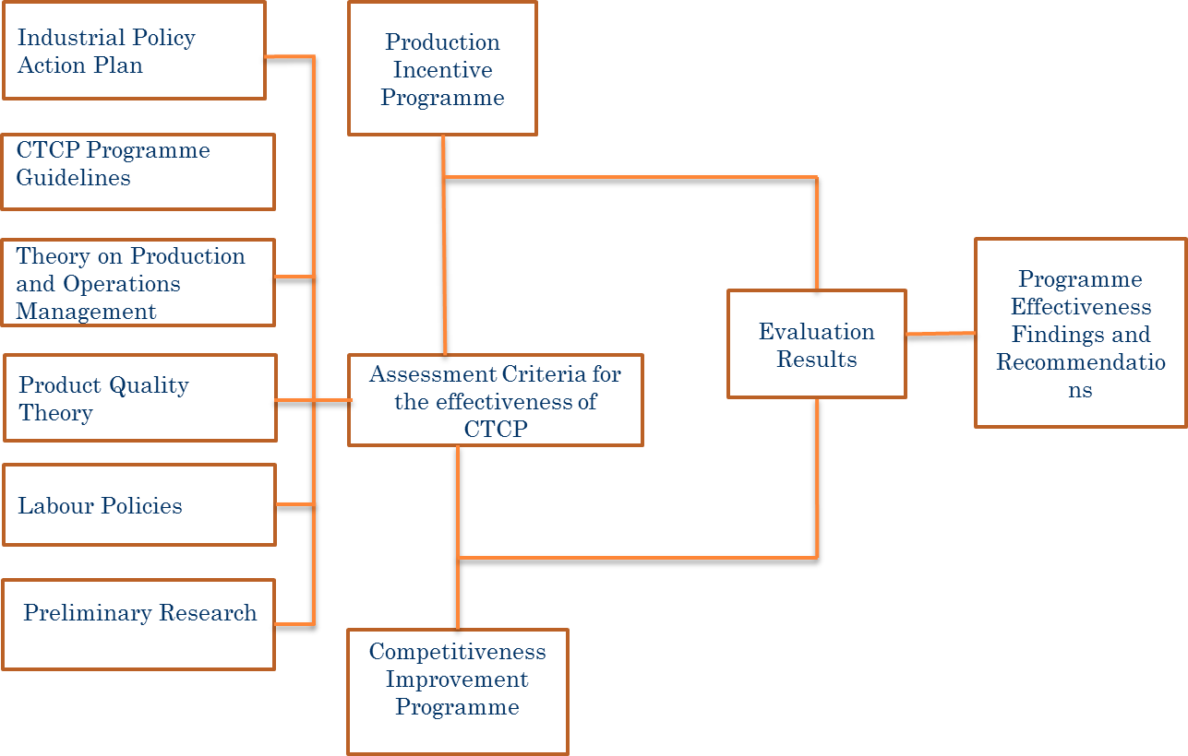

Figure 5 Research framework

A study on the effectiveness of the CTCP based on the relevant literature on the policy for industrial action plan and labour, guidelines on the PIP and on the CIP, theory on product quality, production and operations management as well as preliminary research through interviews with the stakeholders yields to the development of an assessment criteria

by means which the effectiveness of CTCP applied to small, medium and large clothing and textile companies in the regions of Western Cape, Kwa-Zulu Natal and Gauteng can be evaluated

evaluations results will be arrived at

which will yield to the findings of the evaluation results being reported on and used to derive possible recommendations for improving the programme effectiveness.

Research Design

Data Collection Design
The research will be using a quantitative approach to reporting the study findings.

Literature review will be conducted through:
- Primary data (organisational documents)
- Literature (Journals, Handbooks, Conference and Seminar papers and Textbooks)
- Media releases
- Questionnaire surveys prepared for interviews with stakeholders
- SASTAC audit reports where possible

Sampling design
The DTi’s database of the registered and active companies within the textile industry shall be consulted by the researcher to determine the population size. The thirty two (32) companies in the SASTAC cluster shall form part of the population. A stratified probability sampling method will be followed whereby the regions of Western Cape, Kwa-Zulu Natal and Gauteng will be selected, the focus will be on the fabric manufacturers and the clothing manufacturers and these will be further classified into small, medium and or large enterprises. Case studies will be conducted on the sampled companies.

The parameters of interest are:
- increased productivity measures in terms of product quality, skills levels and optimisation
- the validity and fairness of production incentive,
- innovation in terms of new developed products and new technologies.

Sampled companies will be visited; the relevant company representatives will be consulted to obtain the required data and information. Individual iinterviews as well as focus groups with the stakeholders will be undertaken and interview questions will be structured.

Proposed Table of Contents of the research report
The proposed Table of Contents of the research report is as follows:

Chapter 1: Background
1.1 Introduction
1.2 Research problem
1.3 Rational for the study
1.4 Research objectives

Chapter 2: Literature survey
2.1 Literature review
2.2 Current Strategies and Policies

Chapter 3: Conceptual method
3.1 Methods to be used in this study

Chapter 4: Research design and methodology
4.1 Research strategy
4.2 Research methodology

Chapter 5: Results – data gathered and analysis
5.1 Data gathering process
5.2 Data gathered
5.3 Data analysis

Chapter 6: Conclusions and recommendations
6.1 Research results
6.2 Recommendations

DATA ANALYSIS

Microsoft Excel will be used as a statistical tool for tabling the data collected, analysing and summarising it in frequency tables and cross tabulation.

SPSS will be used as a statistical tool where binomial logistics regression will be carried in understanding the effectiveness of the CTCP (dependent variable measured on a dichotomous scale of “yes” or “no”) and prediction based on the “production incentive metric”, “productivity” and “innovation”.

ETHICS

When conducting a research, the researcher is ultimately responsible for the integrity of the research process and the dignity and as wellbeing of the research subject. Saunders, Lewis and Thornhill (2009:193) state that the data collection stage is associated with a range of ethical issues. The ethical considerations are as follows:

Ensuring participants have given formal consent
The concept of informed consent refers to the importance of fully disclosing the procedures of the proposed survey or other research design before requesting permission to proceed with the study (Cooper & Schindler, 2014:31). The targeted respondents will be required to provide consent after the researcher has explained the study benefits and the rights and protections of the targeted respondent.

Ensuring no harm comes to the participants
According to Cooper and Schindler (2014:39) it is the researcher’s responsibility to design a project so that the safety of all interviewers, surveyors, experiments or observers is protected. The researcher will ensure that no harm comes to the participants or targeted respondents.

Ensuring confidentiality and anonymity
According to Cooper and Schindler (2014:33) the researcher should ensure that the identity of all participants is protected. The researcher will adhere to this.

Ensuring that permission is obtained
It is important that official channels are cleared by formally requesting permission to carry out a study (Saunders, Lewis and Thornhill, 2009:194). For this research permission has to be obtained from the targeted organisations to conduct this research.

COPYRIGHT

The university’s guidelines on copyright prerequisites will be met by the researcher.

TIME SCHEDULE

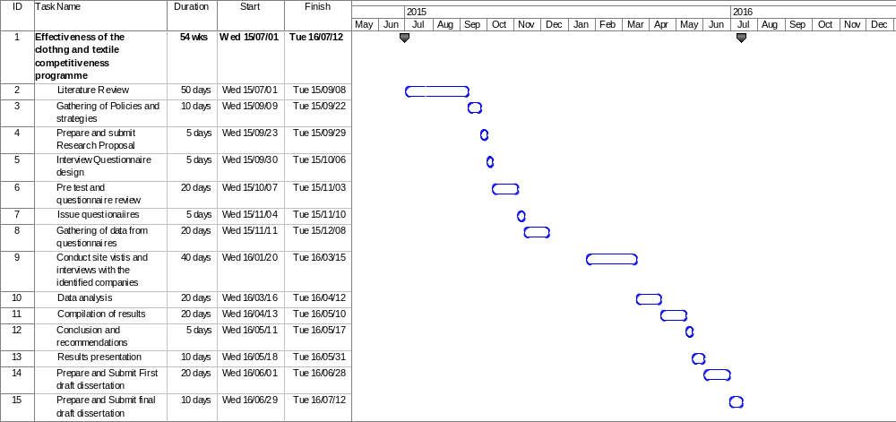

Figure 6 Proposed schedule of the research study in Gantt chart format

SUPPORT STAFF

Arrangements will be made with the support staff (Supervisor) to be allocated to the researcher by the university prior to the commencement of the research.

BUDGET

The following table shows the estimated budget for the research.

Table 1 Budget

Activity Description | Amount
Subsistence and travel | R25 000.00
Printing of questionnaires, interview questions and reports | R1 000.00
Total | R26 000.00

The travelling costs will be borne by the researcher and include flight and kilometres to be travelled costs related to:
- travelling to industry for conduction of interviews and data gathering
- travelling to cluster meetings
- accommodation

The printing costs are estimated and will be borne by the company as I will be utilising company resources. The researcher will endeavour to distribute the survey questionnaires electronically. Interview questions will only be printed to be utilised by the researcher during interview with identified industry stakeholders. Binded hard copies of the final report will be for the university.

RECORDS

Records of the research report will be kept as follows:

  - at the university for a period of 3 years.
  - a copy of the final report to be kept by the researcher and
  - a copy of the final report will be kept by the organisation’s corporate compliance department.

PUBLICATIONS

The report could be published by the South African Institute of Industrial Engineers Journal. The researcher is a member of the institute and was also a council member of the institute. The researcher is knowledgeable of the requirements of the institution for journals publishing.

References

Department of Trade and Industry see SOUTH AFRICA.
Department of Trade and Industry. SOUTH AFRICA. 2015. Industrial Policy Action Plan Economic Sectors, Employment & Infrastructure Development Cluster IPAP 2015/16-2017/18. [Online]. Available from http://www.thedti.gov.za/DownloadFileAction?id=1017 [Accessed: 23/08/2015].

Statistics south AFRICA 30 March 2015. Quarterly employment statistics. [Online]. Available from http:// www/statssa.gov.za/publications/P0277/P0277March 2015.pdf [Accessed: 23/08/2015].

Department of Commerce, International Trade Administration see UNITED STATES OF AMERICA.
Department of Commerce, International Trade Administration. UNITED STATES OF AMERICA. US Trade with sub Saharan Africa, January–December 2014. [Online]. Available from http://www.trade.gov/agoa/pdf/2014/us-ssa-trade.pdf. [Accessed: 16/08/2015].

MORRIS M & BARNES J (2006). Regional Development and Cluster Management:
lessons from South Africa. [Online]. Available from http://www.cssr.uct.ac.za/sites/cssr.uct.ac.za/files/pubs/prism_regional_development_cluster_management.pdf [Accessed: 20/07/2015]

Department of Trade and Industry see SOUTH AFRICA.
Department of Trade and Industry. SOUTH AFRICA Version 6. Programme guidelines competitiveness improvement programme for clusters in the clothing, textiles, footwear, leather and leather goods industries. [Online]. Available from http: //www.ctcp.co.za/tmp/Competitiveness%20Improvement%20Programme%20Guidelines.pdf. [Accessed: 12/06/2015].

Department of Trade and Industry see SOUTH AFRICA.
Department of Trade and Industry. SOUTH AFRICA. April 2014 version 1. Programme guidelines for production incentive programme FY2014/2015.[Online].Available from http://www.ctcp.co.za/tmp/PIP%20GUIDELINES%20%202014-2015.pdf [Accessed: 12/06/2015].

ACTS see SOUTH AFRICA.

SOUTH AFRICA. 1994. Public Finance Management Act, No.1of 1999 [Online]. Available from http: /www.treasury.gov.za/legislation/pfma/act.pdf [Accessed: 11/06/2015].

SOUTH AFRICA. Department of Trade and Industry. 2014. Media release, Government approves R200-million grant for the Southern African Sustainable Textile and Apparel Cluster (SATAC). [Online]. Available from http:/www.thedti.gov.za/editmedia.jsp?id=3062. [Accessed: 20/07/2015].

BARNES J (2005) A strategic assessment of the South African clothing sector. [Online]. Available from http://www.tips.org.za/file/barnes_nedlac_clothing.pdf [Accessed: 17/07/2015]

Saunders, M.N., Lewis. P. & Thornhill, A. (2009). Research methods for business students. 5th Edition. England: Pearson Education Ltd.

Cooper D.R. & SCHINDLER P.S. (2014). Business research methodologies. 12th Edition. New York: McGraw-Hill

